RESEARCH METHODOLOGY

UNIT 1: Research Problem

Problem Solving –

General Problem Solving

Logical Approach

Soft System Approach

Creative Approach

Group Problem Solving Techniques for Idea Generation

Formulation of Research Problems –

Approaches to Research Problem

Exploration for Problem Identification

Hypothesis Generation

Formulation of the problem

MEANING of Research

- Search for Knowledge

- (scientific and systematic search)

- Art of scientific investigation

Research comprises

- defining and redefining problems

- formulating hypothesis

- collecting, organising, evaluating data

- making deductions and reaching conclusions

at last, testing the conclusions to see if they fit the formulating hypothesis

OBJECTIVES of Research

(discover answers to questions)

- To gain familiarity with a phenomenon or to achieve new insights into it (exploratory research);

- To portray accurately the characteristics of a particular individual, situation, group (descriptive research);

- To determine the frequency with which something occurs or with which it is associated with something else (diagnostic research);

- To test a hypothesis of a causal relationship between variables (hypothesis-testing research)

GENERAL PROBLEM SOLVING

Perceived Difference b/w “what a situation is” and “what it should be”

Closing the gap, Reducing the difference

TYPES

Simple: Components and interrelationships are transparent

Complex: Several subsystems interact in ways difficult to understand

Well-defined: When problem definition is proper

Ill-defined: When problem definition is not sure. It may be redefined

Wicked: Alternatives are too many, Solutions are not accurate

Several technologies for Power Generation

PROBLEM SOLVING PROCESS

1) It starts with Identifying the Problem

2) Data gathering (objective and subjective data)

3) Definition of problem is made. Redefn after viewing from angles

4) Ideas are generated to solve problem (ind and group approach)

5) Ideas are evaluated and solutions are obtained

6) Best solution is implemented

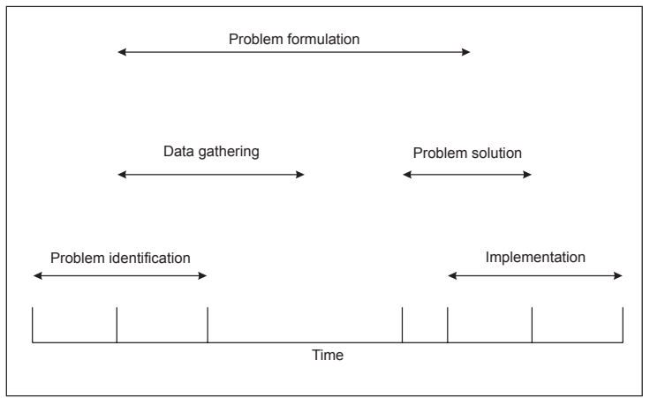

LOGICAL APPROACH

Problem is abstracted and expressed

- mathematically

- diagrammatically

- descriptively

Techniques: Linear Programming, Dynamic Programming

- Breaking the problem into parts

- Solving backwards from final desired solution

- Each backward step leads to what is required from the start

Morphological Analysis: Logical approach to search for new ideas, used to develop new products

Attributes are listed. In grid. Combinations of these atttributes
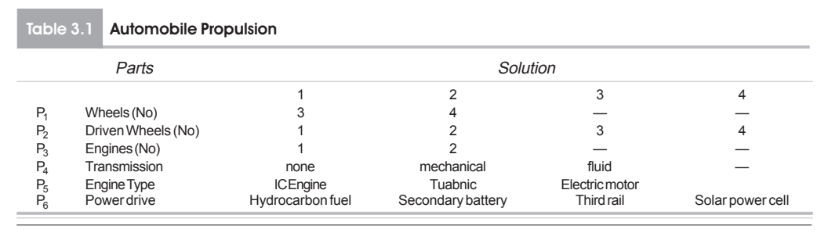

Potential Problem Analysis: Systematic analysis using structured questionnaire. To identify what can go wrong, what can be done

SOFT SYSTEM APPROACH

All complex details (opinions, reactions) are obtained qualitatively.

Clear differentiation bw client, problem solver, problem owner with roles of them listed for ease of communication.
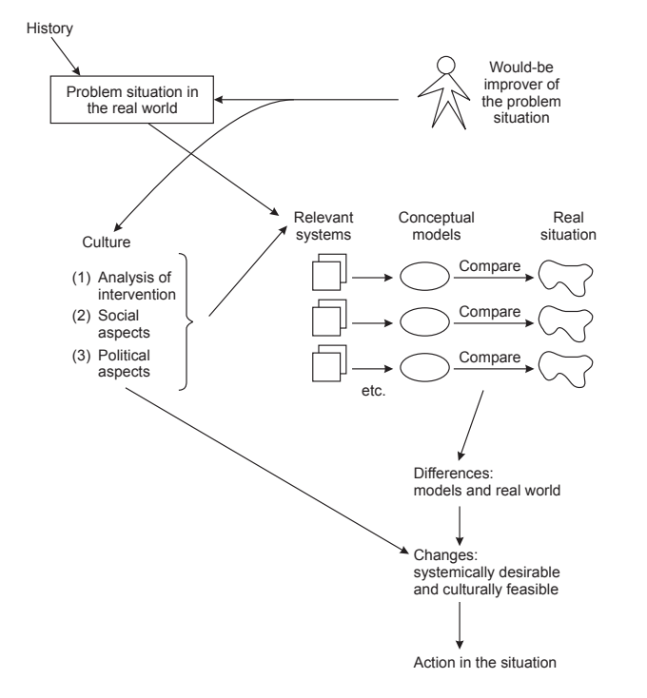

Conceptual model is developed using the human activity system

CREATIVE APPROACH

To make original contributions, one needs creativity

Requires

- absence of mental regimentation,

- strong motivation,

- freedom of self expression

It leads to a thinking process that can solve a problem in a novel way

Thinking Process:

Logical/Analytical: Vertical, Critical, Strategic

Creative/Heuristic: Lateral, Divergent, Outcome

Stage of Creative Process:

1) Preparation: Problem is investigated intensely, later given up

2) Incubation: Stage at which individual is relaxed

3) Illumination: Idea occurs

4) Verification: Idea is evaluated

GROUP PROBLEM SOLVING TECHNIQUES FOR IDEA GENERATION

- Formalized group of people come together

- to identify problem, develop solution

- Diverse viewpoints throw light on several aspects of problem

- Members interact to make idea generation efficient

- Number of new ideas can be created: Brainstorming, Delphi

Brainstorming: 6-10 members from different backgrounds respond to central questions. The members express their ideas without evaluation the ideas of others

Delphi Method: Survey technique. Achieves consensus among isolated anonymous members. It gets expert opinion on problem

APPROACHES TO MANAGEMENT RESEARCH PROBLEM

1) Management Problem is posed to the researcher

- Decision-maker seeks a scientific solution from a researcher

- The researcher's role is akin to that of a doctor

- The researcher translates the problem into research questions.

- Research Methodology

Exploratory Stage: Involves feasibility assessment, system studies, and interviews to understand the problem's context and organizational dynamics.

Formulation Stage: Uses a systemic view to analyze how problems in one area might stem from issues in another subsystem of the organization. This leads to the formulation of research problems typically addressed using statistical or mathematical models.

- Types of Research:

Hypothesis-driven Research: When knowledge gaps exist, hypotheses are formulated and tested.

Applied Research: Directly applying existing methods to solve the problem.

Developmental Research: Creating new methods or modifying existing ones to suit specific organizational needs.

- Evaluation and Solution: Researchers evaluate alternative methods for solving the problem and select the most suitable. If necessary, they develop new approaches tailored to the organization.

Overall, the researcher plays a critical role in identifying, formulating, and solving management problems through systematic analysis and application of research methodologies, akin to diagnosing and treating issues as a doctor would.

2) Initiation of a Novice/Student to Research

A novice research student sources research ideas from origins,

- guidance from their research supervisor

- by conducting a literature review to identify gaps in

They usually follow a two-step process:

- formulating a tentative hypothesis or model

- conducting a pilot study to test its validity

This pilot study helps confirm the appropriateness of the variables, measures, and data collection instruments.

Based on the pilot study's findings, modifications are often necessary before the student develops a full research design

EXPLORATION OF RESEARCH PROBLEMS

Research problems are rarely handed to researchers.

They often emerge from difficulties that lack clear solutions.

Initial expressions of these problems are vague and require rigorous questioning to clarify their significance and novelty.

Researchers must explore existing literature, observe phenomena, consult experts, attend conferences, engage in brainstorming, and reflect critically to identify viable research problems.

Literature Scanning:

Examine existing research to identify knowledge gaps.

Phenomenon Observation: Studying decision problems faced by managers through system analysis (System Study)

Expert Discussions: Engage with experienced professionals for diverse insights, facilitated by technology.

Conferences and Seminars: Attend events for ideas and suggestions from scholars.

Brainstorming Sessions: Collaborate with groups to generate potential problem ideas.

Creative Reflection: Reflect on the problem area through critical questioning and inquiry.

HYPOTHESIS GENERATION

It is a tentative statement about population that is true or wrong.

Problem is formulated as a question.

Hypothesis is suggested solution that could be tested.

Theoretical framework is a precursor to hypothesis generation.

Characteristics of Good Hypothesis

Hypothesis generation is creative process. Large number is generated

1) Conceptually Clear

Meaningful, Communicable, Compatible with existing knowledge

2) Empirically Based

3) Must be Specific in order to facilitate Testing

If necessary, split up into sub hypotheses

Education standard is declining (nursery, high school, college)(region)

4) Hypothesis should be Deduced from Theory

It should be connected to theory

5) It should correspond with existing knowledge

6) It should be formulated in simple understandable terms

7) It must be verifiable

Characteristics of a Good Hypothesis:
Clear and Concise: Easy to understand and test.
Specific: Well-defined and unambiguous.

Testable: Can be proven through experimentation or data analysis.
Falsifiable: Can be proven wrong if evidence contradicts it.
Relevant: Aligns with the research question or problem.
Simple: Avoids unnecessary complexity and assumptions.
Measurable: Quantifiable outcomes or variables.
Feasible: Can be tested within practical constraints (time, resources).
Original: Contributes new knowledge or insights.
Theoretically grounded: Based on existing theories or frameworks.

Process of Hypothesis Generation
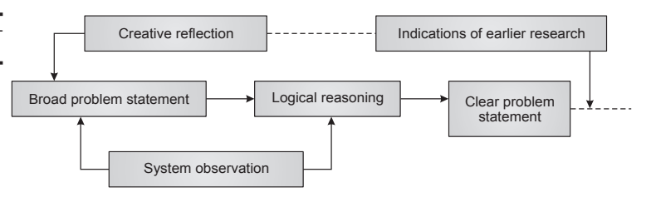

The hypothesis generation is an iterative process that involves:

creativity, critical thinking, and systematic approach.

Literature review: Quick review of existing research to gain knowledge and insights.

Pilot studies: Preliminary investigations to clarify the problem and identify gaps.

Problem statement: Defining the problem as a gap or unanswered question.

Variable identification: Determining relevant variables related to the problem.

Theoretical framework: Building a conceptual model of relationships among variables.

Hypothesis formulation: Converting the problem statement into testable hypotheses.

Challenges in Hypothesis Generation

Absence of theoretical framework

Lack of logical utilization of theoretical framework

Limited knowledge of research techniques

Strategies for Overcoming Challenges

Replicate earlier work

Start with a broad theory and deduce relationships

Use assertions based on commonsense (after critical examination)

...

UNIT 2: Research Design

Experimental Research

Principles of Experiment

Laboratory Experiment

Experimental Design

Quasi Experimental Design

Action Research

Validity and Reliability of Experiment and Quasi Experiments

Ex Post Facto Research

Exploratory Research

Historical Research

Descriptive Research

Field Studies

Survey Research

Qualitative Research Methods

Principles of Experiment

The majority of managerial decisions are made on the basis of observations of relationships among variables.

Manufacturing manager may observe that people high on aptitude tests usually obtain high merit rating scores after one year service in the firm. Such inferences on relationships show only associative relationships. No cause-effect relationship is implied.

Sometimes the manager wants to make an inference on the relationship like whether a special programme of training a specific grade of workers will increase the productivity of the workers. In such cases he will have to base his inference on theoretical foundations based on experimentation.

Causal inference is based on the following logic,

If variable P causes variable Q then:

• Changes in P will cause changes in Q

• P will always occur before Q

• To infer that P causes Q, other possible causes must not exist.

Experiments have been conducted in such management areas as

Marketing:

Evaluating new products, selecting ad themes.

Production:

Production control systems, inventory policies, lead time uncertainties, job design effects on productivity.

Personnel:

Training methods, organizational structures.

Finance:

Portfolio selection, investment decisions.

R&D:

Project control.

There are a variety of methods available for experimentation.

They are,

Laboratory Experiment: Controlled environment experiments.

Uncontrolled/Natural Experiment: Observing natural occurrences without interference.

Ex Post Facto Experiment: Tracing back the cause from an effect after an incident in a natural setting.

Trial and Error Experiments: Used by laymen for practical problem-solving.

Controlled Observation Study: Systematic observation under controlled conditions.

Field Experiments: Includes action research, evaluative research, and simulation experiments.

These principles guide the design and execution of experiments to ensure valid and reliable results, essential for making informed managerial decisions.

BASIC TERMINOLOGY

1) Experiment:

A set of one or more runs of a system under specified conditions

2) Experimental Unit:

The study object from which data are collected. Known as 'subjects' in human-related research (psychology, marketing, ergonomics) or 'test units' in engineering research.

3) Factor:

An independent variable in an experiment.

Qualitative Factors: Nominally or ordinally scaled attributes

Quantitative Factors: Measurable on interval or ratio scales.

Manipulative Factors: Values can be changed (price in marketing).

Classificatory Factors: Values cannot be changed (brand).

Blocking Factor: An independent variable that can affect.

Factor Level: The specific value of a factor.

4) Nuisance Variable:

A measurable quantity that cannot be controlled but affects the dependent variable(s).

5) Treatment:

A specific experimental condition denoted by a combination of treatment-factor levels.

Treatment Group/Experimental Group: Experimental units subjected to a particular treatment.

6) Experimental Design:

The research design of the experiment, detailing data collection, sample size, and analysis. Includes specifications on Independent variables held constant, Design factors (independent variables), System outputs to be measured.

7) Subject Variables/Organismic Variables:

Individual variables carried by subjects (items experimented upon).

Laboratory Experiment

Laboratory experiments create precise conditions where some variables are controlled and others are manipulated, allowing observations on dependent variables.

The hallmark of laboratory experiments is the exactness of situations and control, which facilitates the refinement of the manipulation process.

Laboratories are not meant to replicate real-life situations but rather to depict pure, controlled environments. While hypotheses and insights may arise in real-life settings, definitive results and explanations are often derived from laboratory experiments. The artificial conditions in the lab allow researchers to verify and elaborate on knowledge obtained from observations or field studies.
However, several difficulties arise during laboratory experiments in management research.

- The strength of variables is often weak in laboratory settings, potentially resulting in no measurable change in the dependent variable.

- Manipulating multiple variables simultaneously is challenging, especially when the manipulation relies on verbal instructions.

- Additionally, variables may prove irrelevant if no relationship is found or if the manipulations are not strong enough to evoke a response in both the control and experimental groups.

The first step in experimental design is to state the problem in experimental terms, clearly and specifically.

This involves careful planning, including details on data, data collection methods, sample size, and required analysis.

A reliable measurement device, such as a questionnaire or test, must be developed.

Any deficiencies in the design should be rectified through interactions under the same conditions or through trial experiments.

Executing a laboratory experiment involves several considerations, such as selecting subjects, determining the group size, considering the cognitive aspects of subjects, choosing group activities, orienting subjects, controlling and manipulating variables, and ensuring accurate measurement.
Errors in laboratory experiments can arise from various extraneous factors, leading to variations in experimental designs aimed at minimizing these errors. Key potential errors include:
History: Pertains to extraneous variables occurring between pre- and post-measures, affecting the dependent variable.

Pre-measurement: Changes in the dependent variable solely due to initial measurement.

Maturation: Systematic psychological, organizational, or physical processes affecting dependent variable measurements over time.

Selection: Unequal control and experimental groups regarding the dependent variable, minimized by random assignment or blocking.

Interaction Error: Changes in the effect of an independent variable due to altered respondent sensitivity or responsiveness after pre-measurement.

Instrumentation Error: Changes in measuring instruments over time due to factors like fatigue or loss of interest.

Reactivity Error: Occurs due to the artificiality of experimental conditions affecting human subjects.

Mortality: Loss of subjects during an experiment, which may differ between groups.

Timing Errors: Inappropriate timing of measurements, minimized by taking measurements over a period.

Surrogate Situation: Differences between experimental environments or sampled populations and actual situations, leading to errors.

Experimental Design

In experimental design, the amount of information generated is measured by variance, confounding, and bias.

Variance indicates the precision of the generated information, Confounding measures the confidence with which values can be asserted, and Bias shows how closely the estimated values reflect their true values.

Various experimental designs aim to reduce these measures. For example, factorial designs help reduce variance, confounding, and bias, which tend to be large in one-at-a-time experimental designs.
The process of designing experiments generally involves five steps:

Definition of Goals: Defining what the experiment aims to achieve.

Identification and Classification of Variables: Determining and categorizing dependent, independent, intermediate, and extraneous variables or factors.

Development of a Model: Establishing a relationship between independent and dependent variables through methods like linear regression, hypothesis testing, ANOVA, ANCOVA, etc.

Choice of Experimental Design: Selecting an appropriate design, run conditions, and using tools such as standard designs, computer programs, or graphical methods.

Validation of the Design: Ensuring that the chosen design is valid and reliable.

Principles of Modern Experimental Designs

Modern experimental designs are based on principles of inductive logic, as propounded by John Stuart Mill. These principles, also known as canons, form the basis of systematically determining causality in experiments. The key canons are:

1) Method of Agreement:
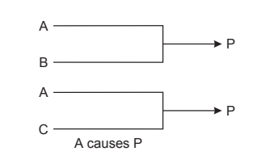

If two or more instances of the phenomenon under investigation have only one circumstance in common, the circumstance in which alone all instances agree is the cause (or effect) of the given phenomenon. This means that if a particular factor is present in all instances where the phenomenon occurs, it can be identified as a potential cause.

2) Method of Difference:
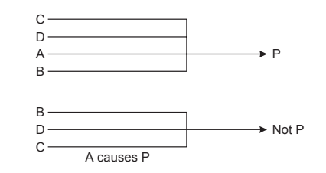

If an instance where the phenomenon occurs and an instance where it does not occur have every circumstance in common except one, the one occurring only in the former is the effect, cause, or a necessary part of the cause of the phenomenon. This principle helps identify the cause by comparing cases where the phenomenon occurs with cases where it does not.

3) Joint Method of Agreement and Difference:
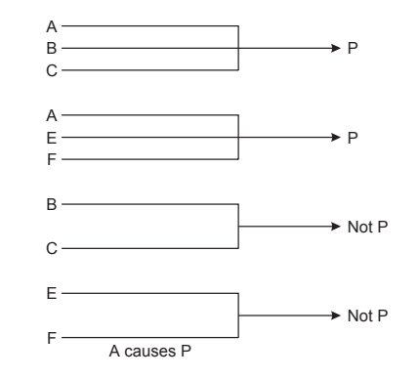

If two or more instances where the phenomenon occurs have only one circumstance in common, while two or more instances where it does not occur have nothing in common save the absence of that circumstance, the circumstance is the effect, cause, or a necessary part of the cause of the phenomenon. This combines the first two methods to strengthen the identification of causal relationships.

4) Method of Residues:

In any phenomenon, if parts are known by previous inductions to be the effect of certain antecedents, the residue of the phenomenon is the effect of the remaining antecedents. This principle is used to isolate the cause of a remaining unexplained part of the phenomenon after accounting for known causes.

5) Method of Concomitant Variation:

Whatever phenomenon varies in any manner whenever another phenomenon varies in some particular manner is either a cause or an effect of the second phenomenon, or is connected with it through some fact of causation. This method identifies causal relationships based on the co-variation of two phenomena.

Quasi Experimental Design

Quasi-experimental designs are employed when true experimental designs are not feasible, providing a method to study phenomena in natural settings.

These designs serve as a middle ground between poor experiments and true experiments, and they have been a viable research method for social treatments throughout the history of social science research.

In quasi-experiments, the random assignment of subjects to treatments is not made, and comparison groups may not always exist. Comparisons in quasi-experiments are typically made between treatment and no treatment on non-equivalent groups or between prior and post-treatment for the same group without having a comparison group.

While quasi-experiments allow for the study and verification of causal relationships, they are subject to certain threats that should be continuously addressed and eliminated through careful data assignments and arguments by the researcher.

Despite their limitations, quasi-experimental designs are valuable for exploring causal relationships in settings where true experimental designs are impractical or impossible.

Here are three types of quasi-experimental designs:

1) Interrupted Time Series Design:
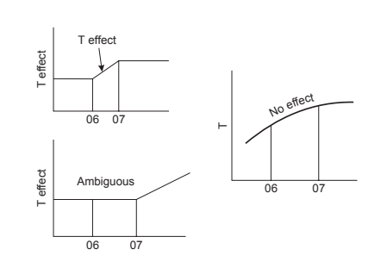

This design addresses the limitations of pre-experimental designs, which are often weak due to the lack of pretest data and threats like selection, history, and mortality.

In an interrupted time series design, the same group is observed repeatedly over time, both before and after a treatment. This longitudinal approach helps mitigate rival threats by allowing for a series of observations to track changes and trends.

The design can be implemented in two ways: with a single treatment applied once or with multiple treatments. By examining differences between pre- and post-treatment observations, researchers can isolate the effect of the treatment from other factors.

However, maturation and history effects need careful consideration, and trends in data should be studied to draw accurate conclusions about causal relationships. A multiple interrupted time series design includes several groups, which helps in testing for threats like history that might affect all groups similarly.

2) Regression Discontinuity Design:
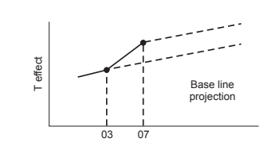

This design involves studying two or more groups at the same time in a cross-sectional manner. It is derived from the static group comparison design, where groups are naturally selected without random assignment.

In this design, one group receives treatment while another does not. The design helps address threats like selection and mortality by comparing results across different groups. The inclusion of multiple groups can provide greater confidence in the causal relationship being studied, as the results are reinforced by the data from various groups.

3) Pre-Test and Post-Test Non-Equivalent Design:
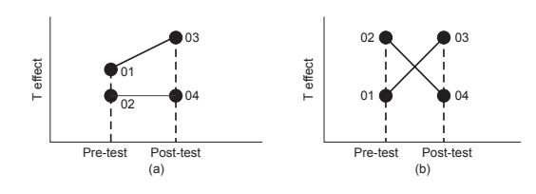

This design combines elements of one-group pretest-posttest designs with pre-experimental designs. It involves pre-existing groups that are not randomly assigned.

One group receives the treatment, while a similar but non-equivalent control group does not. This design allows for the elimination of some threats but may still suffer from issues like maturation interaction. A key feature of this design is the presence of pre-test differences between groups.

VALIDITY OF QUASI EXPERIMENTS

Quasi-experimental designs strive to balance the internal validity of true experiments with the external validity of field studies. They offer a middle ground by studying phenomena in more natural settings without the stringent controls of laboratory experiments. This balance comes with its own set of advantages and challenges.

One of the key strengths of quasi-experimental designs is their higher external validity compared to laboratory experiments. They are conducted in more natural settings, which better reflect real-world conditions and thus provide more generalizable findings. However, the lack of random assignment in quasi-experiments introduces biases from naturally occurring selection, which can impact the results. This non-random assignment means that the subjects may self-select into treatments, which is particularly common in settings like psychotherapy or certain training programs. This self-selection can introduce biases that affect the study’s internal validity.

A crucial aspect of validating quasi-experimental designs involves addressing rival explanations, especially those related to selection bias. Self-selection by subjects, where individuals choose their own treatment, can be more appropriate in some contexts but may still introduce biases that need careful investigation. Random assignment, while ideal for internal validity, can sometimes reduce external validity by making subjects feel like they are part of an experiment or a lottery, which can affect their responses and behaviors.

The challenge in quasi-experimental designs is to find an optimal compromise between internal and external validity. Researchers must carefully design their studies to mitigate biases while ensuring that the findings are applicable to real-world settings. This involves carefully considering the context in which the study is conducted and the nature of the subjects involved.

ACTION RESEARCH

Action research is a form of applied research that focuses on solving practical problems through direct collaboration between researchers and practitioners. This approach is often used to address issues within organizations or communities, emphasizing both immediate problem-solving and contributions to broader social science goals.

Action research is a method aimed not only at discovering facts but also at addressing and improving unsatisfactory conditions within a community or organization. This perspective highlights the dual objective of action research, to provide practical solutions while advancing theoretical understanding.

Rapoport (1970) expands on this by addressing the ethical dimensions of action research. He defines it as a type of applied social research characterized by the researcher’s immediate involvement in the action process. According to Rapoport, action research involves working closely with those affected by the problem within a mutually agreed-upon ethical framework, aiming to address practical concerns and achieve social science objectives.

Forster (1972) builds on Rapoport's definition, emphasizing the connection between researchers and the organizational change process. He highlights that action research not only involves direct participation by researchers but also focuses on creating and implementing organizational changes, thus making it distinct from other forms of applied research.

French and Bell (1978) define action research as a collaborative effort between researchers and practitioners. They stress the importance of this collaboration in diagnosing and evaluating problems within practical settings, underscoring the joint nature of the research process.

The development of action research is rooted in four key streams:

1) The Tavistock Stream: This integrated psychologists, social anthropologists, and psychiatrists to address organizational and community issues.

2) Operational Research: This approach combined social science methods with practical problem-solving techniques.

3) Group Dynamics: Emerging from Kurt Lewin's work, this stream focuses on understanding and improving group interactions and dynamics.

4) Applied Anthropology: This perspective emphasizes the need to consider cultural and sub-cultural contexts when addressing issues such as industrial relations.

Action research, therefore, represents a collaborative, practical approach to research that seeks to effect change while contributing to theoretical knowledge.

PROCESS of ACTION RESEARCH

- The identification of a problem area about which an individual or a group is sufficiently concerned to take action.
- The selection of a specific problem and the formulation of a hypothesis or prediction that implies a goal and a procedure for reaching it, with this specific goal viewed in relation to the total situation.
- The careful recording of actions taken and the accumulation of evidence to determine the degree to which the goal has been achieved.
- The inference from this evidence of generalizations regarding the relation between the actions and the desired goal.
- The continuous re-testing of these generalizations in action situations.

Susman and Evered (1978) suggest a slightly different approach for an action research program, represented as a block diagram.
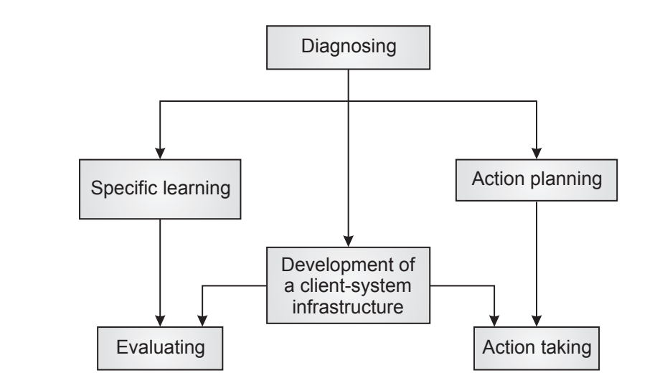

A comparison between the two approaches indicates that although there are minor variations in the steps, the overall philosophy remains the same. It is important to note that these are general guidelines, and an actual action research plan may involve overlaps and differences depending on the setting and context of the organization in which the research is conducted.

EX POST FACTOR RESEARCH

- This research is conducted with regard to events or phenomenon

- After they occur, As they are happening

- It is concerned with non manipulated variables of a phenomenon

- Always bias. If X then Y. But there’s Z affecting Y

- "ex post facto" translates to "after the fact" in Latin

It is a type of research design where researcher examines data from events that have occurred, rather than conducting experiments or collecting new data.

Pure Research

Field of Genetics, Studying genome of fruit flies to understand principles of inheritance. Research on the role of “specific gene” in fruit fly may not have immediate practical application, but it contributes to the fundamental knowledge in genetics

Applied Research

Engineers and Material Scientists working on developing graphene based water filter. Applied research in this area aims to address practical challenge of providing clean drinking water

Diagnostic Research

A hospital conducts diagnostic research to investigate the causes of a sudden increase in post-surgical infections among patients in its orthopedic ward.

Evaluation Studies

A nonprofit organization conducts an evaluation study to assess the impact of its community literacy program on school children in a rural area.

Action Research

A manufacturing company is experiencing frequent delays in production due to equipment breakdowns. The production manager initiates action research to improve operational efficiency.

Experimental Research

Pharmaceutical company (BioPharm Innovations, Inc) is developing a new drug to treat hypertension. They conduct an experimental research study to test the efficacy of the drug.

Analytical Study

A research team conducts an analytical study to investigate the association between dietary habits and the prevalence of obesity among adults in a metropolitan area.

Survey Research

A market research firm conducts a survey to gather insights into consumer preferences for electric vehicles (EVs) in a major metropolitan area.

Research Process
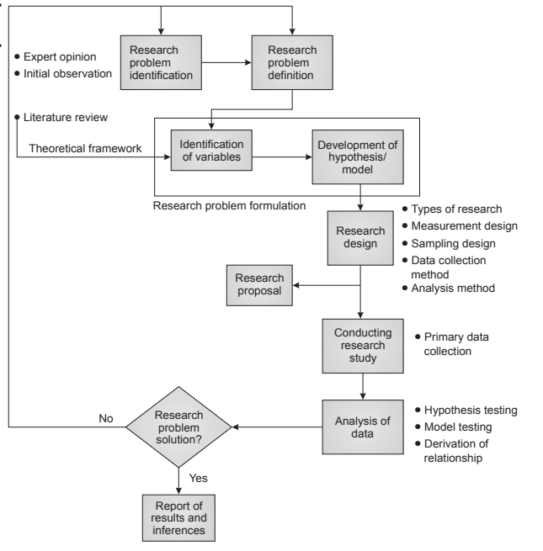

Exploratory Research

A university sociology department conducts explorative research to investigate the impact of social media on the mental health of adolescents.
It is the preliminary study of unfamiliar problem (or) about a topic in which the researcher has little or no knowledge.
Aim: generate new insights, problem identification.
Flexible Design: Open ended approach without rigid constraints allows to uncover new variables and patterns
Hypothesis Generation: It is about HG instead of hypothesis testing
Qualitative Methods: It employs QM (interviews, focus groups) to
gather information and understand context
Data Collection:
- Search for secondary source of information
- Obtaining information from knowledgeable persons
- Examination of analogous situation

Historical Research

A historian conducts historical research to explore the socio-economic factors that led to the Great Depression in the US during the 1929.
It is concerned with some past phenomena.
Evidence about past is systematically collected, evaluated, verified.
Difference from other kinds of research:
We perform logical analysis based on other’s experience and opinion
- (a) Historical Problem in management
- (b) Historical View of current management problem
Steps:
- Data Collection
- Critical analyses of data
- Validation
Primary Data: (Observer/Participant) Oral account of eye witness
Secondary Data: (Non Observer) Books, Journals, Remains,...
Chronological Approach: It examines events over time to understand their development and consequences.
Example:
- Trends in silk production growth in Karnataka during 1930-1995
- Impact of the Industrial Revolution on Urbanization of Britain 1890

Descriptive Research
A company that sells organic fruits conducts a descriptive research to gather demographic information and buying habits of its customers in the specific region of Los Angeles to understand their preferences. The objective is to provide a detailed snapshot of customers.
It is a fact finding investigation with adequate interpretation.
It involves describing, recording, analyzing and interpreting conditions that exist.
Aim: Provide the what, where, when, who, why, how of the event
Aim: Describe the event objectively, without variable manipulation
Quantitative (statistical data, numerical counts)
- It uses simple analysis of data (central tendency, SD, correlation)
- These statistics obtained MUST be discussed, interpreted
- Just gathering data is not considered research

Qualitative (detailed narratives, analysis)
- Data should lead to development of thinking, elaboration of patterns
- And generalizations
It has hypothesis generation, and testing

Field Studies

- It is aimed at hypothesis testing
- of relationship in real world situations

- (studies of classrooms, groups, community,..)

- No manipulation of independent variable is undertaken
- It has great depth of information
- It has less generalization capability (because variations are large)

- They are micro in nature, focusing on a single group

Types:

- Descriptive field study with large generalization

- Participant Observation

Survey Research

Research method involving collection of data from a sample

Sample is a predefined group of people
Aim: To understand their opinions, behaviours, attitudes, characters.

Steps:

- Involves systematically gathering information

- Through structured questionnaires, interviews

- Analysing the responses

- To make generalizations about a larger population

Eg: Times of India carries out surveys in aspects Education

Data Gathering

1) Observe the people, event directly

2) Communicate with people about the event

Survey Methods

1. Personal interviewing

- Yields deep and rich information.

- Researcher has control over quality and quantity of information

- Expensive but interviews in central places can reduce cost.

- Interview schedules can be used.

2. Telephone interviews

These are useful in arranging personal interviews and screening large populations of unusual respondents, and is a unique mode of communicating with respondents. Computer assisted telephone interviews (CATI) are used in research organisations

3. Self Administered survey

- Most popular and widely used
- The questionnaires

- Sent by post, faxing, e-mail, internet services

- The cost is low and coverage can be very large.
- Unlike in interviews, the respondent has time to think the answers.

Qualitative Research Methods

Information is captured using qualitative reasoning.

These methods rely on interviewing (in depth to get view of event)

Aim: Describe the meaning of naturally occurring event

Methods: Case Study, participant observation, ethnographic method, critical incidence technique, repertory grid technique, projective techniques, protocol analysis, cognitive mapping, diary method.

Case Study Research

Complete analysis and report of a subject with all the phases.

While a case study details the facts of an organisation situation, there is a need for qualitative reasoning to get generalisation and interpretations.

It is in depth in nature.

It is non-statistical approach

It can include development of a unit (phases)

Observation, reference to documents, interviews, content analysis, messages, questionnaires are all used.

Participant Observation

It is an inductive form of research

Helpful in the generation and modification of hypotheses.

Suitable to the socialisation process, career analysis of managers, and roles played by both individuals and groups in organisations

Methodology: Researcher will observe the events regarding the hypothesis. Contradicting event can enrich the hypotheses.

Ethnographic Methods

Ethnography is the process of studying and describing a culture.

It is concerned with description and analysis of culture.

Aim: Understand the native’s point of view, his life, his vision

Aim: Provide an insider’s picture of the community under study.

Types: Document the life, Focus on one aspect

Critical Incidence Technique

Set of procedures for collecting direct observations of human behaviour.

It is intended for collecting incidents having special significance

An incident is defined as any observable human activity, which is complete enough to enable one to make inferences and predictions regarding the person performing it. The situation of the incident must be known to the observer and the objective and intentions of the performer and their effects must be understood clearly.

The technique has several steps as follows:
- Finding out the general aim of the activity in the incident—this is done by obtaining a consensus of authorities in the field of the problem.
- Designing plans and specifications for collecting data regarding the activity/incidents— this should help in classifying and analysing behaviour by the observer.
- Collecting data about the incident—this may involve interviews or written statements by the observer. The data must be objective, recorded statement of factual aspects and should be devoid of opinions, hunches, and impressions of the observer. Critical inci- dents provide only raw data in this sense and do not provide any answers or solutions to the problem at hand.
- Analysis of data—efficient summary of this data must be obtained so that it can be used in application. To a certain extent this may tend to be subjective.
- Interpretation and derivation of the activity requirements.

Repertory Grid Technique (RGT)

The theory underlying the technique is that people engage in making sense of their world by evaluating incoming social data and translating it into decisions. They tend to formulate hypotheses to test them against the experience and to renew them. The technique is simple to apply and computer analysis is possible with it.

The RGT is used in several disciplines. It has many possibilities of application in management research. The theory is concerned with understanding cognitive structure, but is loose. The RGT is structured but content-free and will help in drawing up an individual’s mental map.

What the researcher should bear in mind is that the meanings of the respondents in a research situation are far more important than their own meanings. For example, how the manager views his associates and his environments while making a decision is more important than the researcher’s construct about the decision-maker’s environment.

The three basic areas of RGT construction are:

Elements: These can be products, roles, situations, or people.

Constructs: Qualities that are evaluatory attributes of elements are called constructs. The method of triad is applied in developing constructs. Elements can be written on card.

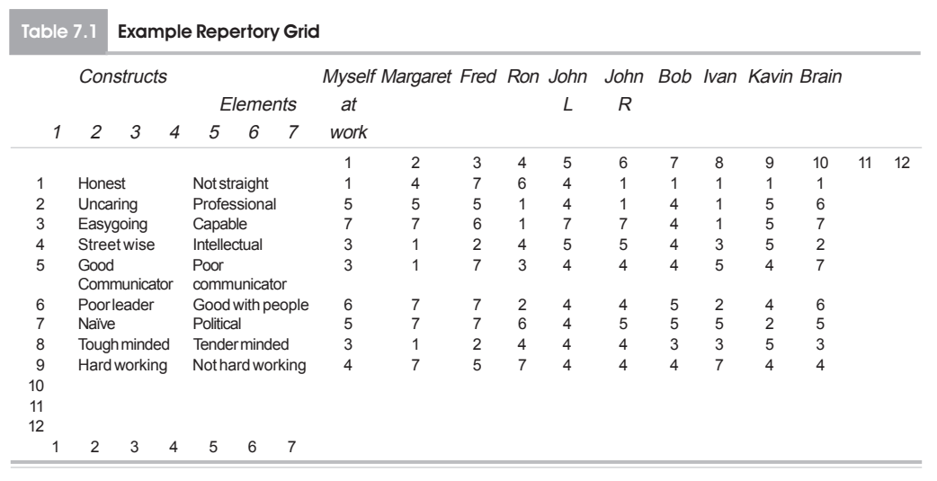

-
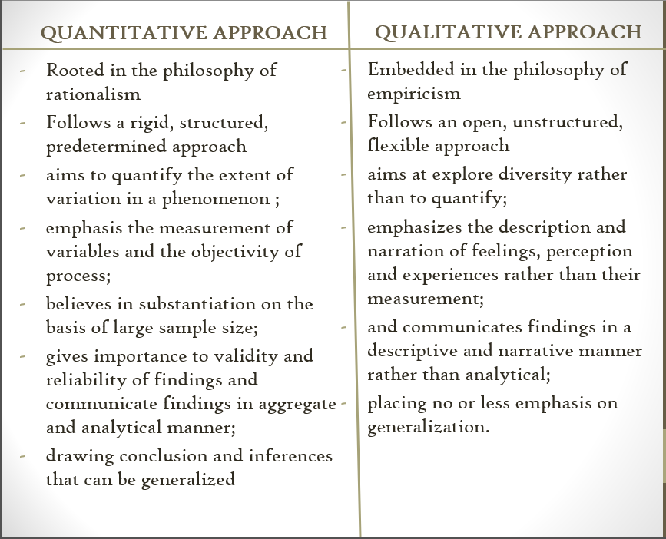

UNIT 3 - Research Design for Data Acquisition

Measurement Design

Primary types of Measurement scales

Validity and Reliability Measurement

Sample Design

Non-Probability Sampling

Probability Sampling

Data Collection Procedures

Sources of secondary data

Primary data collection methods

Validity and Reliability of data collection procedures

Measurement Design

Primary types of Measurement scales

RESEARCH is as good as the DATA that is used in it

DATA is as good as the MEASUREMENT done on it

Assignment of numbers (to objects) to represent quantity

Matching of an entity of one domain with another

Characteristics of number: Order, Distance, Origin

Results in Scales of Measurement

Nominal Scales

Measurement procedure to classify objects into categories

- lowest level of measurement

- classification measurement

- objects are classified into categories

- category has a label

- widely used: social sciences

- eg: telephone numbers

- (numbered categories doesn’t have order, distance, origin)

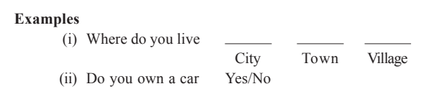

Ordinal Scales

Scale used to measure data having transitivity property

(x>y, y>z, then x>z)

Includes characters of nominal scale + indicates order

Defines relative position of objects, but there is no determination of distance between objects. Limited to determining >, =, < without explaing the how >, < is the difference

Statistics: median, quartile, ranking indexes can be obtained.

Eg: Costs of product brands

Eg: Ordering objectives by importance
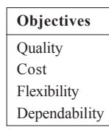

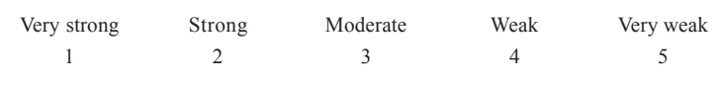

Interval Scales

Includes characters of nominal and ordinal scale

+

Units of measure (intervals between positions)

Truly quantitative

Statistics: All usual statistical measures are applicable

Eg: Scale of temperature [Celsius scale]
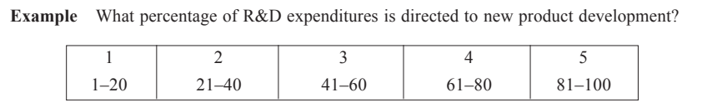

Ratio Scales

It is an interval scale with a natural origin (true zero point)

Possesses all characters of a number system

Enables all types of statistical analyses

Common in the physical sciences:

Velocity, Weight, Length, Area,...

Less so in the social sciences:

Money, Age, Years of Education,...

Validity and Reliability Measurement

Errors in measurement:

- Due to researcher

- Due to instrument

- Due to respondent

Measurement Accuracy = r / t

r: recorded value

t: true value

Validity

Extent to which instrument measures what we wish to measure

(Attempt to measure t and compare it to r)

Reliability

Deals with accuracy and precision of measurement procedure

(Measure of variability in r)

Practicality

Wide range of factors of economy, convenience, interpretability

Validity

The instrument's ability to measure what it aims to measure.

a) Content Validity:

Measures how well the instrument covers the topic under study.
Determined through judgment, or expert panel review. Face validity

b) Criterion-Related Validity:

Used for empirical estimating purpose.

Assesses the instrument's ability to predict outcomes (Predictive)

Estimate current behavior (Concurrent validity)

c) Construct Validity:

Evaluates how well the instrument measures the underlying theoretical construct.

Assessed through MTMM matrix (multi trait multi method)
- convergent validity (correlation with other measures)
- discriminant validity (lack of correlation with unrelated variables)

Reliability

Reliability indicates accuracy and precision

Reliability indicates stability and consistency

Not valuable as Validity

Stability: Ability to maintain consistency over time.

Equivalence: Consistency across different investigators, samples

Sample Design

Population: Entire group of study objects

Sample: One object (smallest), One less than population (largest)

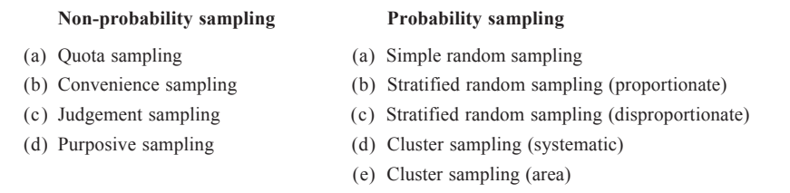

Non-Probability Sampling

Judgement based procedure

It can be representative

But precision and confidence cannot be obtained

Quota Sampling

Most commonly used

Subclasses (strata) are estimated from external sources (census).

Sample size is allocated to each stratum in proportion to its population size.

Individuals within each stratum are selected by researcher judgment.

Therefore selection bias is present.
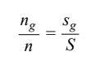

n = overall population, ng = grades

S = sampling quota, sg = people selected by judgement

Judgement Sampling

Sample is obtained based on sound judgement or experience

Intention is to choose representative subjects

Dependance on expertise is good for small samples

Snow Ball Sampling

Multiplicative sampling (or) Mixed sampling

Used for studying special characteristics of population

Initial subjects with desired characters are randomly selected.

Then next subjects are selected through referral or info from initial.

This procedure increases probability of finding subjects with desired characters.

Eg: Employees of company (initial), Competitors (obtained)

Purposive Sampling

Similar to judgement sampling, but sample is chosen so that a particular research purpose is served and is adequate for it

Sample is typical rather than representative

Eg: Small Scale employees are chosen

Convenience Sampling

Ad Hoc procedures (or) Accidental Sampling

Whatever is easily accessible, subjects who are cooperative are chosen. They are not representative and not recommended for research

Probability Sampling

Random Sampling is employed

The process is objective

Objective assessment of reliability is possible

But representativeness may not be assured

However sampling error can be computed in this

Simple Random Sampling

Each population element has equal chance of being selected.

300 objects. 5 sample size.

260, 310, 620, 73, 750, 180, 190, 660, 290
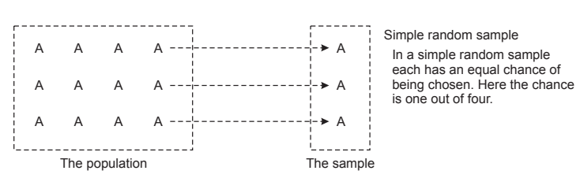

- Mean of samples = Mean of population

- Distribution of sample means is normal

- SD of sample means = Standard Error

Stratified Random Sampling

Population is stratified (partitioned)

Partitioned based on different features

Random sample is drawn from each partition (stratum)

Sampling Error is considerably reduced in this
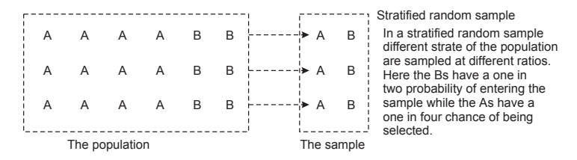

Cluster Sampling

Similar to stratified sampling

Population is divided into sub-groups

Random sample is selected from each sub-group

Difference from stratified sampling:

Sub-groups are sampled as well

Random selection of subsets, then selection of elements from subset

- Not preferred from statistics pov

+ Economical

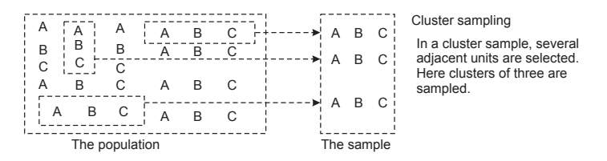

Systematic Random Sampling

Random beginning (first choice) is made

Every Lth item is then selected

+ Easy sampling procedure

+ Can be more representative

- Periodicity in the population can cause serious error of estimation

Area Sampling

Sampling area divided into sub areas at different levels
(sub areas at States, Districts, Cities,...)

Level wise random samples are chosen

Single stage area sample: One level of sampling (countries/blocks)

Multi stage area sample:

(a) Nation (India, USA, Australia)

(b) States (Karnataka, Texas, NSW)

(c) Districts (Udupi, Austin, Adelaide)

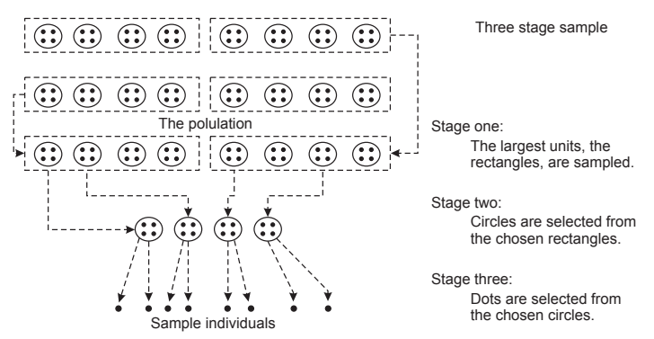

Data Collection Procedures

Sources of Secondary Data

Data collected by a researcher for their own use,

which is now of use to another research project

It is searched for and obtained from many different sources

Internal Sources

Company Accounting Data

- Accounting and Financial details

- Maintained in ledgers and computers

- Inventory, Purchase, Logs, Shop Orders, Payment ledger, Cashbook

+ Provide data close to primary data

Company Reports

- Annual Reports, Regular Reports

- Submitted to board of directors

- Statutory Reports submitted to Government

- Insights about operation and performance

In-house Journal

- Most corporations publish in-house journals

- Useful general data can be obtained

Miscellaneous Reports

- Consultancy reports, Special reports, Novel reports

Company Computer Database

- Use of internal data for decision making has increased

- Intranet (internal networks links to internet, but forbids access)

- Distributed Databases

Enterprise Data Warehouse (Data Marts)

- Started to rise in the last 20 years

- Data Warehouse is collection of information from various sources

- They are processed (ETL) and stored in the database

- Available for Decision Making, Business Suport and OLAP

External Sources

Public Computer Database

- Large Databases

- Available to access at a charge

- Finance, Marketing, Employment, Product Sales,..

Reports of Associations

- Associations of industries

- Electrical manufacturing association, Automobile, IETF

- Provide details of industry’s sales growth, characters,...

- Publish special reports and research statistics

- Newspaper and Magazines collect information from them

Reports of government agencies

- Central and State government

- Provide large amounts of data on finance, R&D, operations

- RBI bulletins, Census, Surveys, Reports,..

- Demographic details, housing, wages, income, sales, agriculture,..

Industrial Syndicates

- These organizations provide data on industrial services

- Area wise info on manufactured products, inventories, sales,..

Other Publications

- Academic publications, Books, Journals, Project Reports,

- Dissertation,

- Computer search systems (google)

Primary data collection methods

Multiple methods are used to collect data

- Minimise or Eliminate bias

- Provides greater reliability

Observation

- Most direct form of data collection

- Watching things with a purpose

- It is effective when data is accessible by observation

- (Behaviour of children)

- Three components: Sensation, Attention, Perception

Participant: Researcher is part of group

Non Participant: Researcher does not participate in group

Controlled: Done in laboratory or field

Uncontrolled: Takes place in natural settings

Direct: Researcher is present and observes the event as it occurs

Indirect: Researcher is not present, and recording is used

Interview

- Can be used in all segments of population

- Flexible, Customer-oriented, Questions can be explained

- Systematic conversation between researcher and informant

- To obtain information

- It involves conversations, gestures, facial expression,..

Depth Interview

- Intensive interview aimed at studying informant’s opinion, emotions

- Deliberately aims to eliciit unconscious and personal feelings

Individual Depth Interview: Interviewer freely questions along

Focused Group Interview: Group of people are interviewed

Directive Interview (Structured)

Standard schedule and order and questions

Non-Directive Interview (Unstructured)

No pre planned schedule

Questionnaires

- Less expensive and Preferred

- Used for large samples

- It follows a standard format to obtain data objectively

- It has uniformity

- Anonymity gives greater freedom of expression

Projective Techniques

- Require well trained interviewer

- Evaluations are obtained from “projects” given to respondent

Association Tests: First thought about a thing

Completion Tests: Asked to complete a phrase or sentence

Construction: Respondent is asked to develop a diagram from picture

Cartoon: Respondent interpretation of cartoon

UNIT 4 – Data Analysis

Exploratory Data Analysis

Statistical Estimation

Hypothesis Testing

Parametric Tests

Non-Parametric Tests

Multiple Regression

Factor Analysis

Cluster Analysis

UNIT 5

Research Proposal

Purpose,

Types,

Development of Proposal,

Evaluation of Research Proposal.

Report Writing

Pre-writing consideration,

Format of Reporting,

Briefing,

Best practices for Journal writing.

Research Proposal

- Research needs approval, financial support

- Formal “Research Proposal” is submitted to authority

- It is a blueprint for conducting and controlling the research

Purpose

To clearly communicate the following to the sponsor,

- Need of the research

- Benefits

- Beneficiaries

- Kind of data collected and the means

- Types of analyses

- Duration

- Funds and Facilities required

- Credentials of the researchers

Types

Type of Proposal varies based on type of project.

- Simple Pilot Study

- Research by Corporation

- Research by Students

- Research by Faculty of a University

- Research Organization

Internal Proposals

- Proposal generated within an organization

- Submitted to its management for approval and funding

- Solves immediate organization problem

- Helps product, process development

- Doesn’t emphasise literature reviews and Project Plans like CPM

External Proposals

- Proposal generated within an organization

- Submitted to outside (customer, organization, funding agency)

- It is larger in scope

- Aims to win the funding

- Project Plans like CPM, PERT charts will be necessary

DEVELOPMENT

Management questions are stated. They are converted into Research questions.

Objectives, Data required, Sources of data collection, Methods of analyses, Timetable of activities, Cost are detailed

Format of Research Proposal
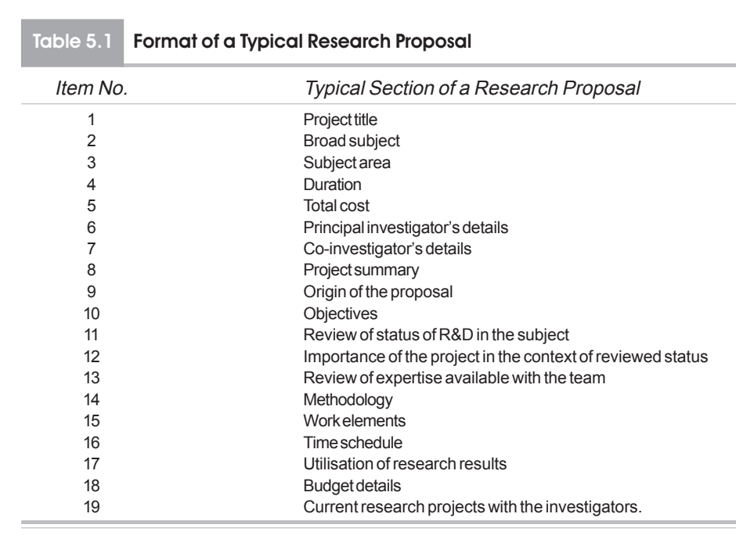

Contents of Research Proposal

Research Objective

It defines what the research aims to achieve, such as testing a hypothesis, answering a research question, or solving a problem.
The research objective should naturally flow from the problem statement and guide the entire proposal, including data collection, analysis, and conclusions.

Research Design

It outlines the phases of the research, including sample size and selection, data sources, and methods of data collection.
Describes the design of research instruments, procedures for data collection, and reasons for chosen methods over alternatives (e.g., why a field study was used instead of experimentation).

Schedule of Work

Timetable: Provides a timeline for major research phases like literature review, pilot study, questionnaire finalization, data collection, data preparation, and report generation.
Project Management: For larger projects, may include a summary network (CPM/PERT) to show interrelationships and project duration.

Credentials of the Researchers

Qualifications and Experience: Includes academic qualifications, positions held, experience, expertise, publications, consultations, memberships, and honors to demonstrate the team’s competence.

Budget

Cost Estimate: Provides a maximum estimated cost of the research, often detailed in a budget format. Includes expenses like literature review, facilities, and other resources.

Literature Review

Focus: Reviews recent studies, company data, or computerized databases related to the research topic.
Critical Analysis: Identifies gaps or shortcomings in current research and justifies the need for the proposed study.
Summary and Bibliography: Ends with a summary of the literature’s relevance and includes a bibliography following research standards.

Evaluation of Research Proposal

Conduct a pilot study to identify loopholes, flaws, and areas for improvement. Modify the proposal based on the pilot study's insights

Unsolicited Proposals: Sponsor Authority evaluates and suggests modifications based on expert feedback

Competitive Bidding:

Develop evaluation criteria and weightage factors

Rate bidders against the criteria

Calculate scores by multiplying ratings and weightage factors

Choose the organization with the highest score for funding

Optional: Use an independent expert panel for evaluation

Report Writing

Research Reports

Vary in scope and treatment, with different formats and styles required by universities, funding organizations, and research journals

Purpose is to efficiently communicate ideas and results to readers

Classified into four types:

Dissertations for research degrees ((link unavailable), Ph.D.)

Organizational research reports for sponsoring organizations

Research papers published in research journals

Contract research reports for client organizations

Each type requires acceptance through:

University panels and oral defense

Sponsoring authority or client organization evaluation

Peer review by research journal referees

Dissertation/Thesis

Read standard books on the subject to prepare

Keep the reader in mind, avoiding assumptions about their familiarity with the subject matter

Learning objectives:

Understand the importance of clear communication

Develop a well-structured outline

Create a draft close to the finished product

Use footnotes for important references

Consider the following before writing:

Purpose of the report

Target audience

Time available for development

Develop an outline after preliminary data analysis, including:

Chapter headings

Section headings

Sub-section headings

Phrases or sentences indicating the sequence of ideas

Focus on the overall structure ("the woods") rather than minor details ("the trees")

Style and Composition

Write clearly, logically, and concisely

Adopt a simple, straightforward, and dignified style

Avoid:

Pedantic language

Bombastic language

Flowery language

Folk style language

Humor

Proverbs

Figures of speech

Use:

Third person (mostly)

First person (sparingly, for personal opinions)

Last name only in references (e.g., "Emory")

Abbreviations (after spelling out first)

Present data using:

Semi-tabular presentation

Tabular presentation

Graphs (line, area, pie, 3D)

Avoid errors in:

Spelling

Subject-predicate agreement

Article usage

Tense consistency

Ensure the report is:

Precise

Unambiguous

Organized

Well-captioned

Easy to understand

Consider the Fog index (Gunning, 1952) for readability standards

Principles of Thesis Writing

Consistency: Maintain consistency in objectives, formatting, referencing, and indentation throughout the thesis.

Logical flow: Ensure a logical transition between sections and chapters, using linking sentences to maintain continuity.

Indentation and organization: Organize the thesis into meaningful chapters and sections, using indentation to enhance clarity.

Coherent presentation: Maintain a continuous and coherent flow of thoughts and ideas within each section or paragraph.

Emphasis and highlighting: Emphasize significant aspects and tone down less consequential ones to provide a proper perspective.

Acknowledging limitations and errors: Frankly acknowledge limitations and errors in data, methods, and tools used.

Clear communication: Use simple language, concise statements, and avoid ambiguity to effectively communicate ideas.

Supporting assertions: Support assertions with evidence from earlier research or facts obtained during the study.

Orderly presentation: Present objectives, variables, and results in a consistent order for easy communication and checking.

Compatibility with data and techniques: Ensure conclusions and inferences are compatible with data and techniques used.

Disciplinary jargon: Use discipline-specific words, modes of expression, and phraseology to demonstrate expertise.

Discernment in elaboration: Develop discernment in elaborating on aspects close to the thesis and concisely outlining distant ones.

Self-contained tables and figures: Make tables, graphs, figures, and illustrations self-contained and easy to understand without needing to refer to the text.

Presenting additional results: Present by-products and related results from additional data or information to enrich the thesis.

Synthetic and analytic approaches: Employ cycles of synthetic and analytic approaches to refine the thesis and identify errors or inadequacies.

FORMAT OF REPORTING
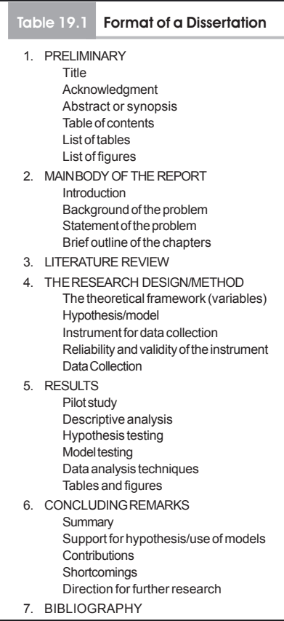

BRIEFING

Briefing: A Condensed Oral Presentation

A 20-30 minute oral presentation of a research report

Clearly understand what to present to the audience

Key elements:

Objectives and nature of the project

Key points standing out

Fluent delivery

Focus on the audience

Restrained delivery

Tips for effective briefing:

Use visual aids

Establish eye contact with the audience

Avoid reading from notes

Practice beforehand (pre-planning and practice-briefing)

Suggested contents:

Project nature statement

Project organization and overview (10-15% of time)

Conclusions and discussions

Recommendations

Question-answer session

Rule for oral presentation:

Fix main points in mind

Use notes/cards or transparencies/PowerPoint slides for connecting information

...

